1. Write a shell script to create n number of files. Where n is an arbitrary integer provided by the user during run time. Name of the files will be file1.text, file2.text, …, filen.text.

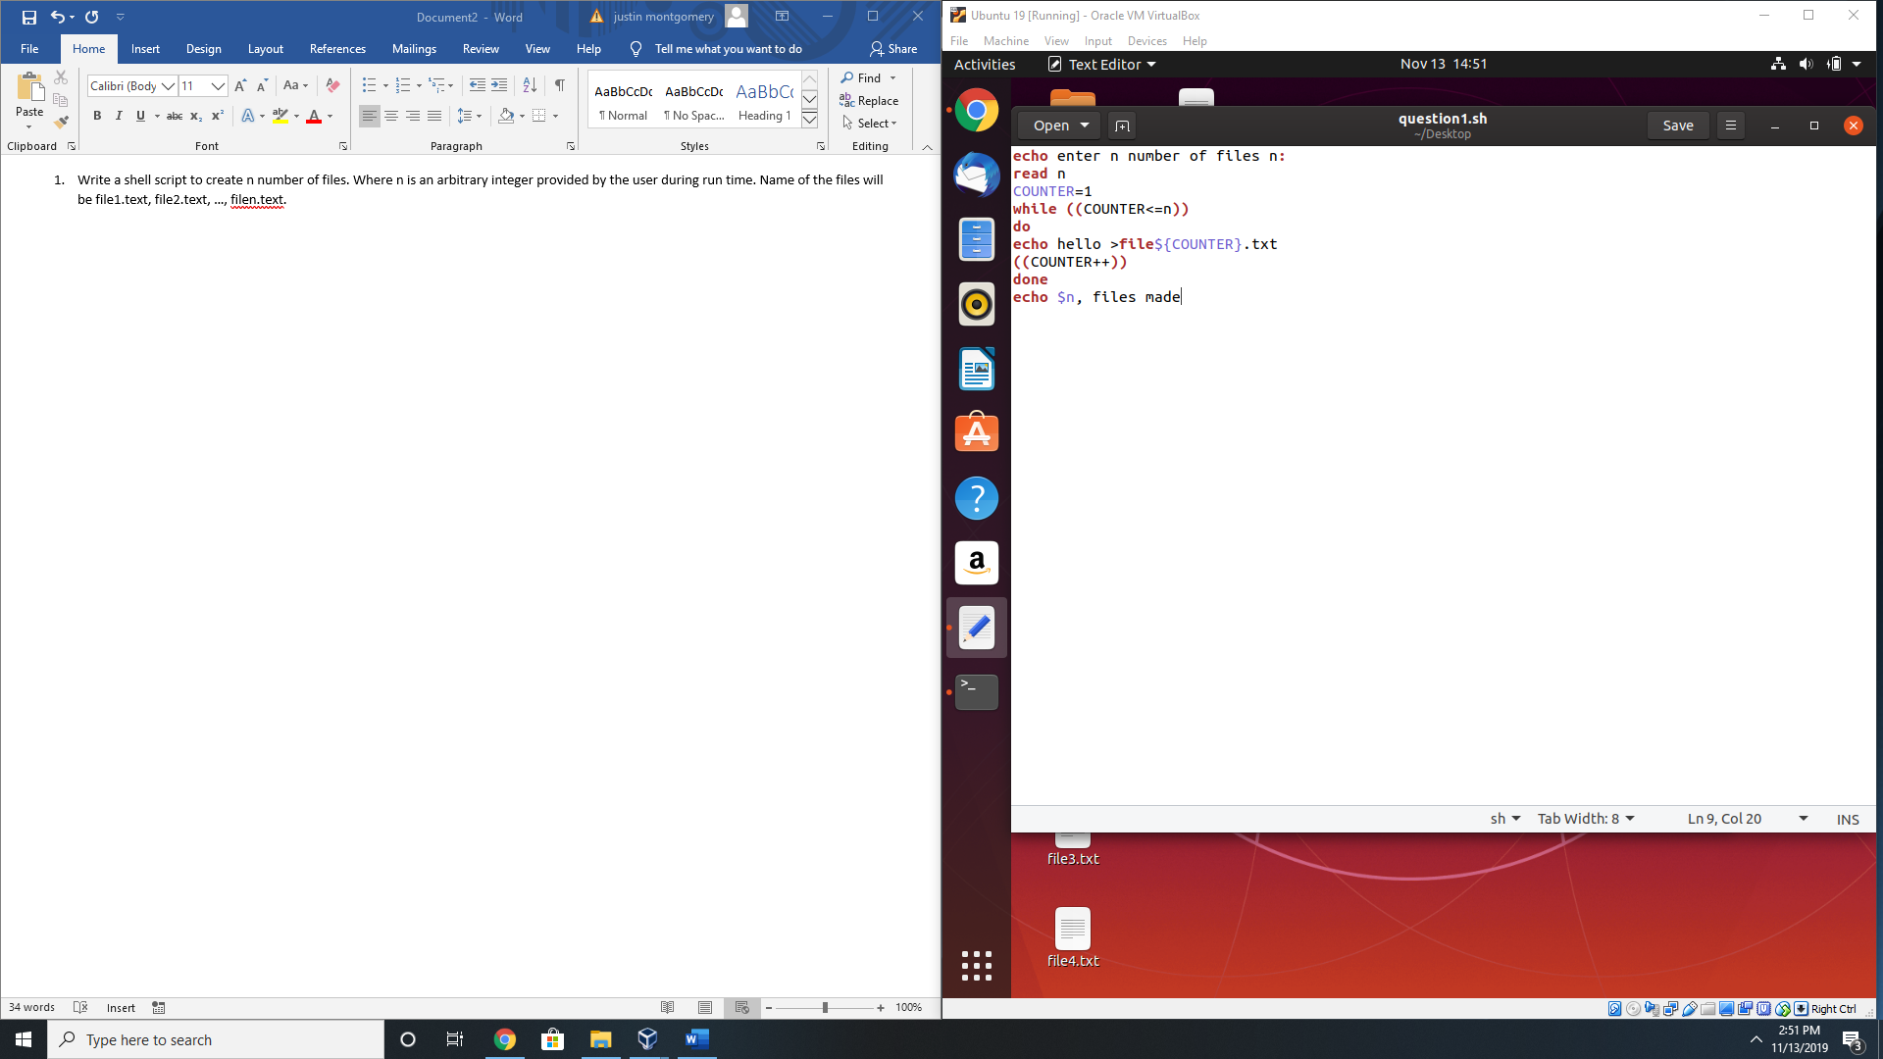

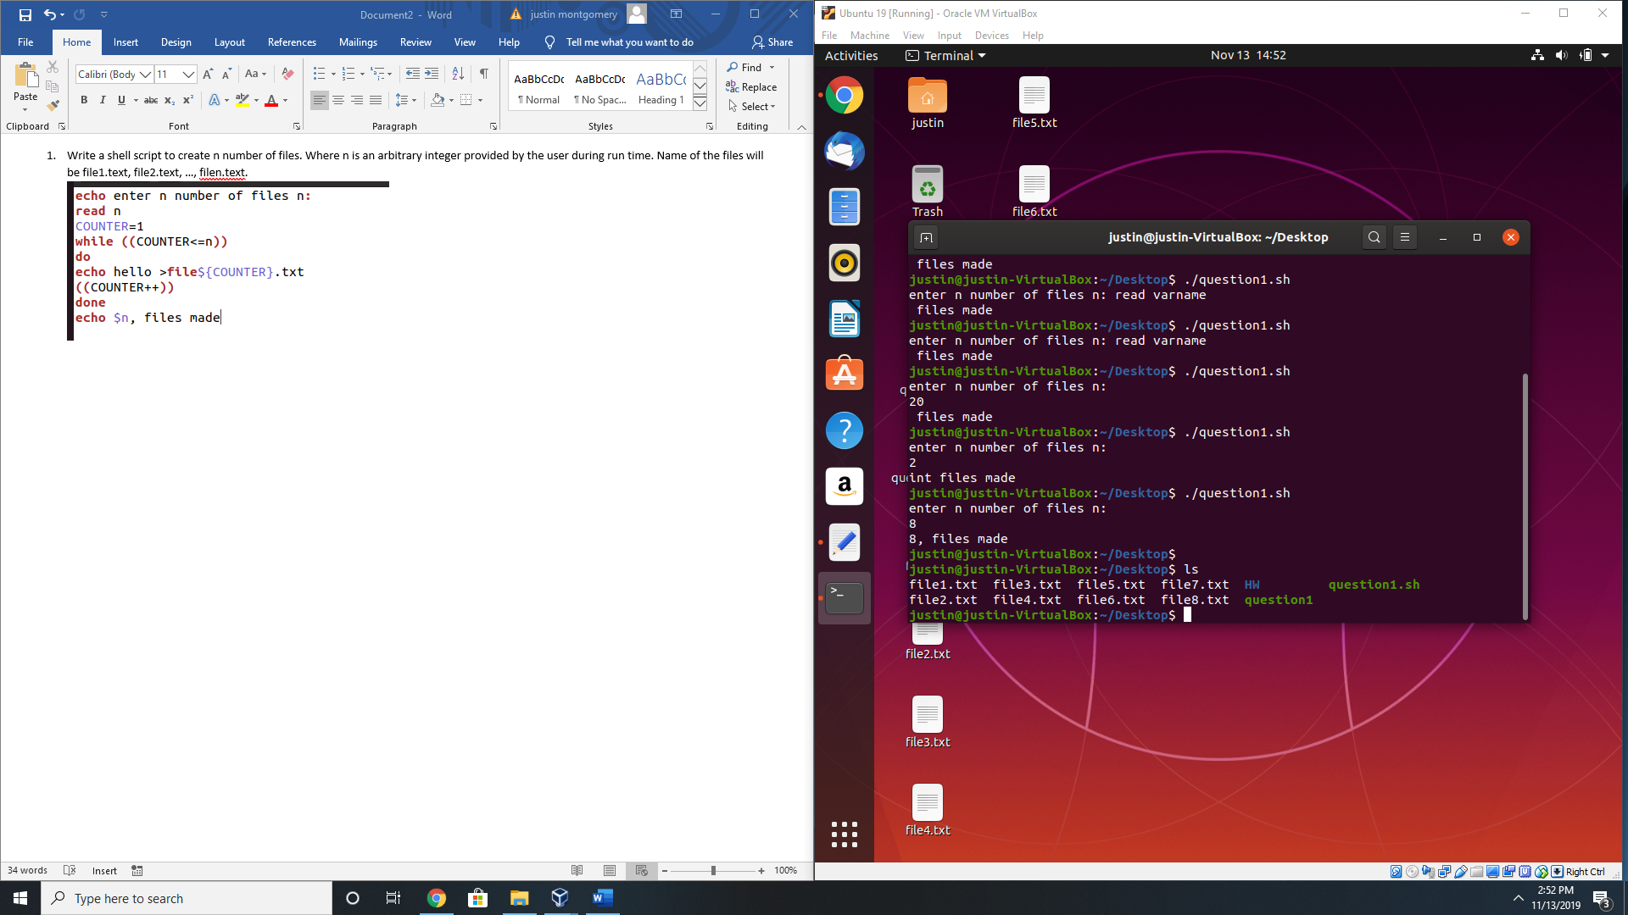

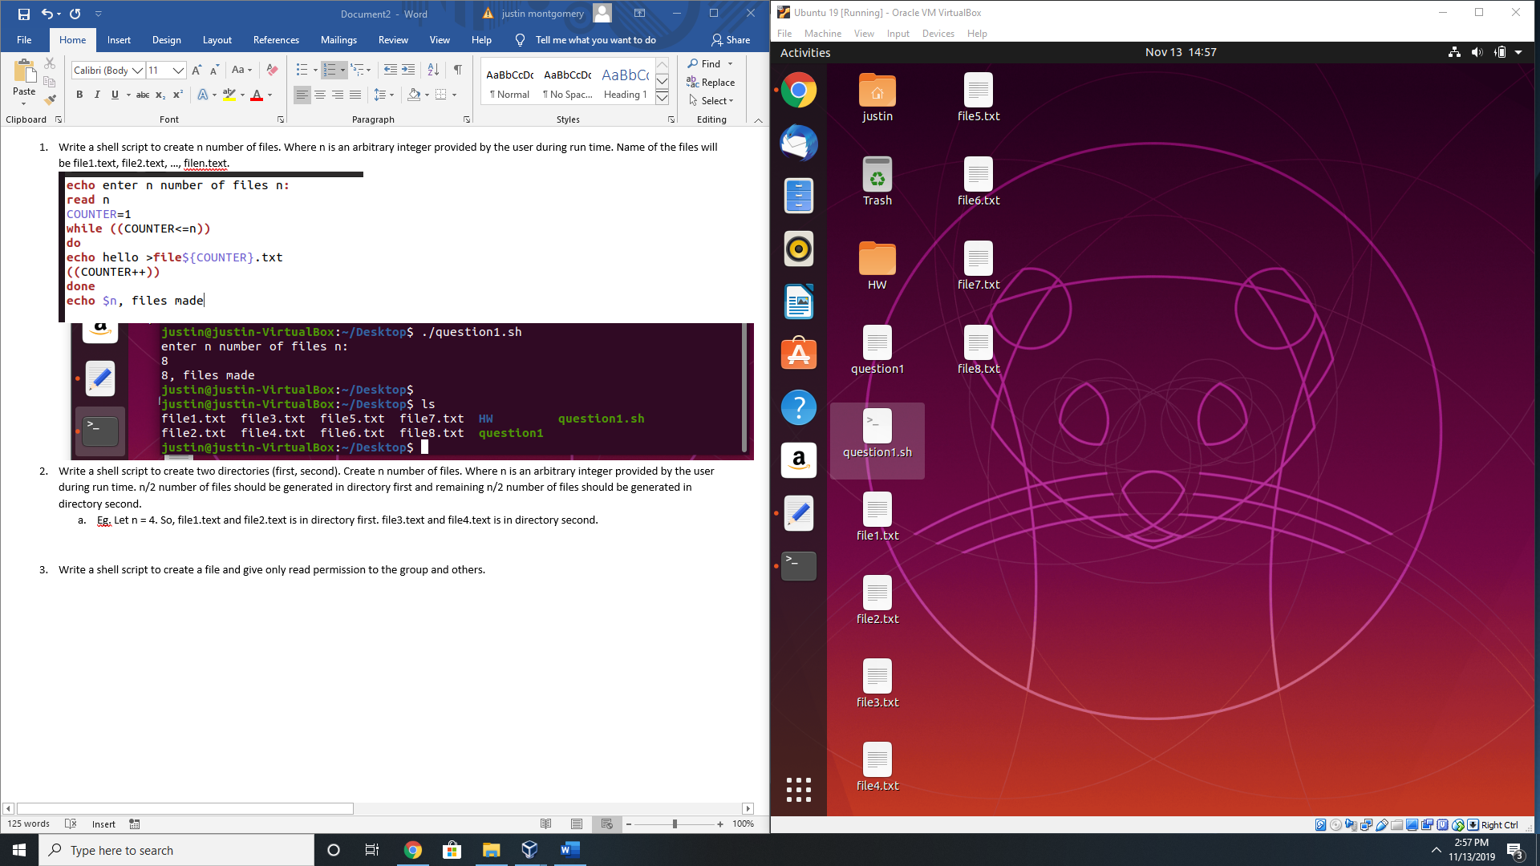

1. Write a shell script to create two directories (first, second). Create n number of files. Where n is an arbitrary integer provided by the user during run time. n/2 number of files should be generated in directory first and remaining n/2 number of files should be generated in directory second.
   1. Eg. Let n = 4. So, file1.text and file2.text is in directory first. file3.text and file4.text is in directory second.

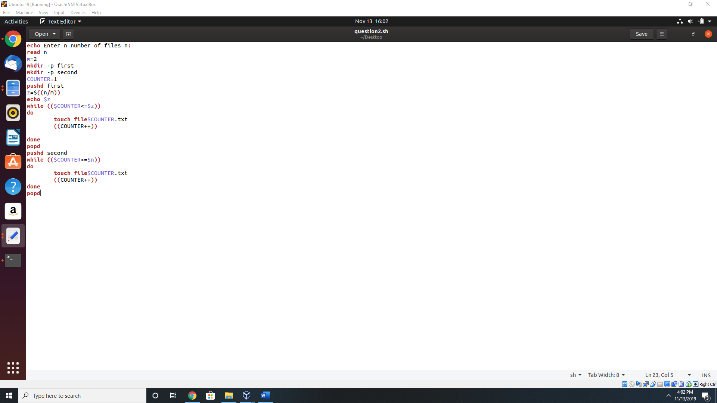

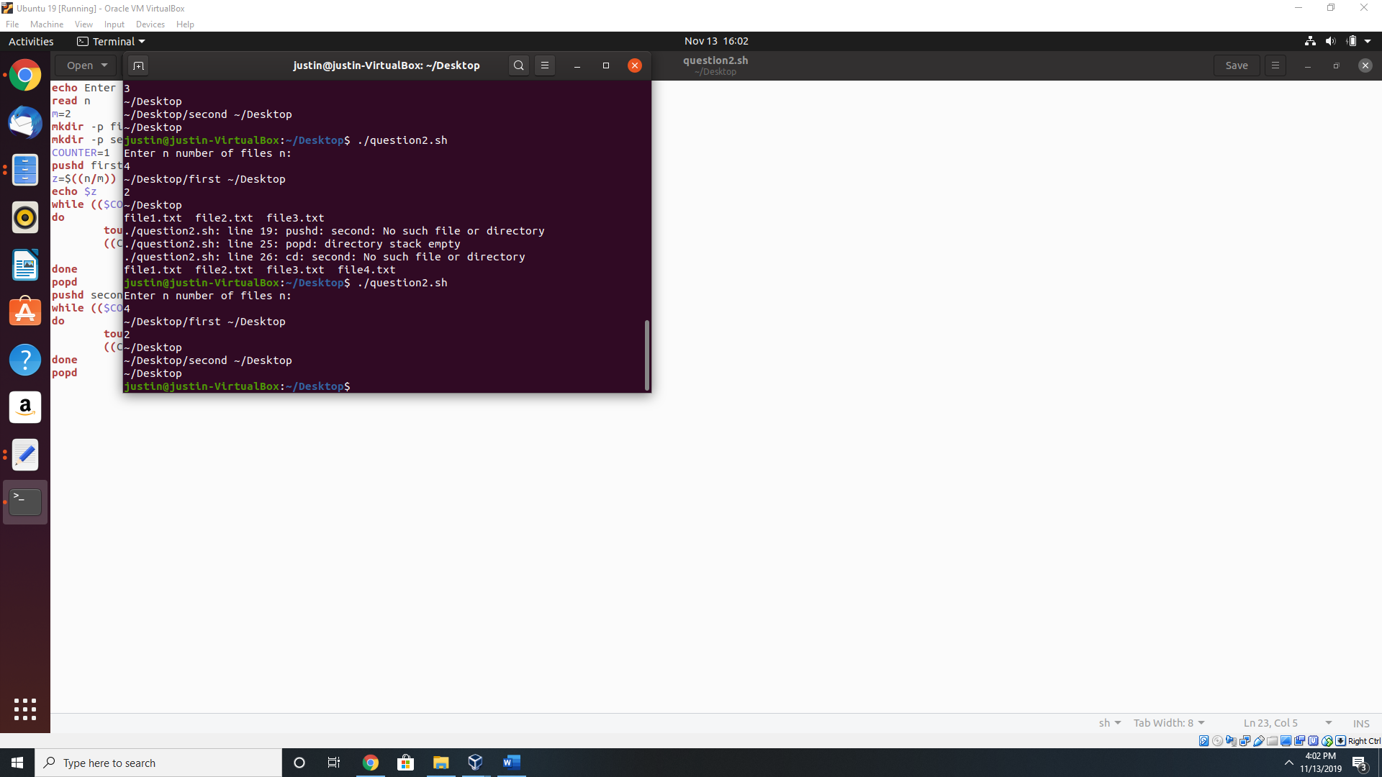



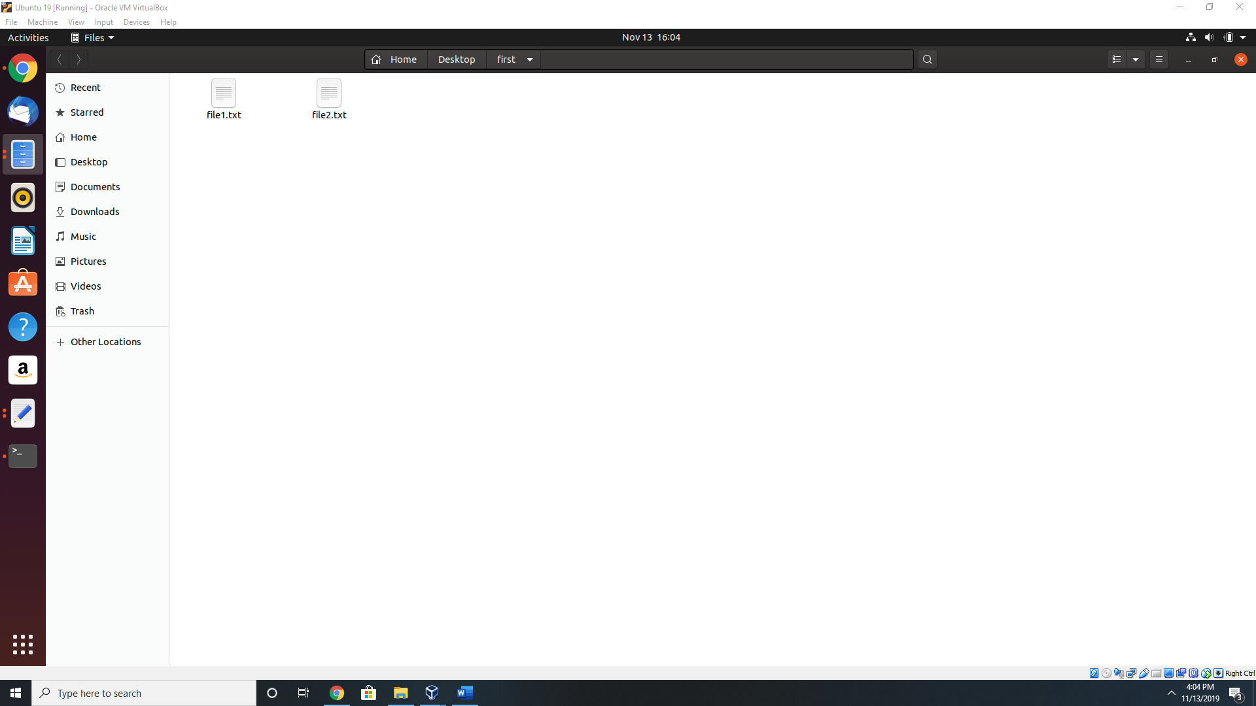



1. Write a shell script to create a file and give only read permission to the group and others.

